**CHANDRU R**

**727721EUIT022**

**IT-A**

**DAY 9:**

**CLASS EXERCISE 1:**

**ECLIPSE CODE:**

package com.selenium.test2.selenium1;

import org.testng.annotations.Test;

import org.testng.AssertJUnit;

import org.testng.annotations.Test;

import io.github.bonigarcia.wdm.WebDriverManager;

import java.util.concurrent.TimeUnit;

import org.openqa.selenium.By;

import org.openqa.selenium.WebDriver;

import org.openqa.selenium.chrome.ChromeDriver;

import org.openqa.selenium.chrome.ChromeOptions;

import org.testng.annotations.DataProvider;

public class Day9 {

//CE1

@Test(dataProvider = "dp")

public void add(Integer n, Integer n1) {

System.out.println(n+n1);

}

@Test(dataProvider = "dp")

public void sub(Integer n, Integer n1) {

System.out.println(n-n1);

}

@Test(dataProvider = "dp")

public void mul(Integer n, Integer n1) {

System.out.println(n*n1);

}

@Test(dataProvider = "dp")

public void div(Integer n, Integer n1) {

System.out.println(n/n1);

}

@DataProvider

public Object[][] dp() {

return new Object[][] {

new Object[] {10,2},

new Object[] {9,3},

}

}

**OUTPUT:**

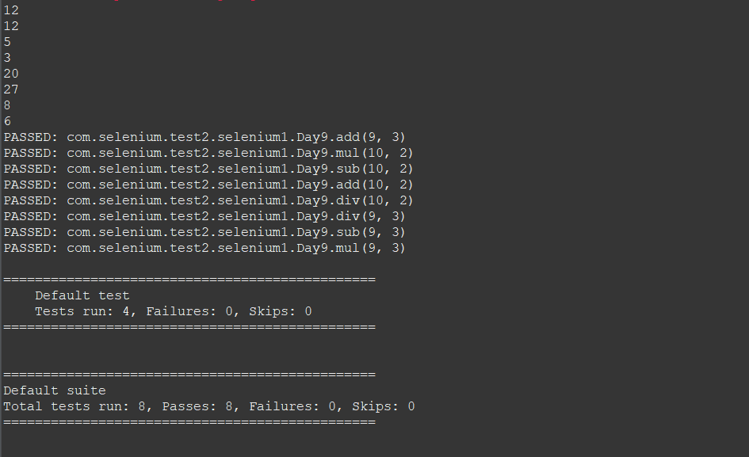

**CLASS EXERCISE 2,3:**

**ECLIPSE CODE:**

package com.selenium.test2.selenium1;

import java.util.concurrent.TimeUnit;

import org.openqa.selenium.By;

import org.openqa.selenium.WebDriver;

import org.openqa.selenium.chrome.ChromeDriver;

import org.openqa.selenium.chrome.ChromeOptions;

import org.testng.AssertJUnit;

import org.testng.annotations.Test;

import io.github.bonigarcia.wdm.WebDriverManager;

public class D9C23 {

@Test

public void f() {

WebDriverManager.chromedriver().setup();

WebDriver driver;

ChromeOptions co = new ChromeOptions();

co.addArguments("--remote-allow-origins=*");

driver=new ChromeDriver(co);

driver.get("https://www.godaddy.com/en-in");

driver.manage().window().maximize();

String actualTitle="Domain Names, Websites, Hosting & Online Marketing Tools - GoDaddy IN";

String extractedTitle=driver.getTitle();

AssertJUnit.assertEquals(actualTitle, extractedTitle);

String actualURL="https://www.godaddy.com/en-in";

String extractedURL=driver.getCurrentUrl();

AssertJUnit.assertEquals(actualURL, extractedURL);

System.out.println("Hello");

//driver.quit();

//driver.manage().timeouts().implicitlyWait(10, TimeUnit.SECONDS);

}

@Test

public void f1() {

WebDriverManager.chromedriver().setup();

WebDriver driver;

ChromeOptions co = new ChromeOptions();

co.addArguments("--remote-allow-origins=*");

driver=new ChromeDriver(co);

driver.get("https://www.godaddy.com/en-in");

driver.manage().window().maximize();

driver.manage().timeouts().implicitlyWait(5, TimeUnit.SECONDS);

driver.findElement(By.xpath("//*[@id=\"id-631b049a-e9c0-4d24-8710-c504745206dd\"]/div[2]/div[1]/ul/li[1]/button")).click();

driver.findElement(By.linkText("Domain Name Search")).click();

//driver.quit();

}

}

**TESTNG CODE:**

<?xml version="1.0" encoding="UTF-8"?>

<suite parallel="methods" name="Suite">

<test name="Test">

<classes>

<class name="com.selenium.test2.selenium1.D9C23"/>

</classes>

</test> <!-- Test -->

</suite> <!-- Suite -->

**OUTPUT:**

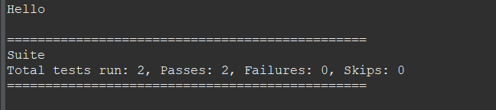

**CLASS EXERCISE 4:**

**ECLIPSE CODE:**

package com.selenium.test2.selenium1;

import org.testng.annotations.Test;

import io.github.bonigarcia.wdm.WebDriverManager;

import org.testng.annotations.BeforeMethod;

import org.testng.annotations.Parameters;

import org.openqa.selenium.By;

import org.openqa.selenium.WebDriver;

import org.openqa.selenium.WebElement;

import org.openqa.selenium.chrome.ChromeDriver;

import org.openqa.selenium.chrome.ChromeOptions;

import org.openqa.selenium.edge.EdgeDriver;

import org.testng.annotations.AfterMethod;

public class D9C4 {

WebDriver driver;

@Test

public void f() throws Exception {

Thread.sleep(3000);

WebElement uname=driver.findElement(By.name("username"));

WebElement pwd=driver.findElement(By.name("password"));

WebElement submit=driver.findElement(By.xpath("//*[@class='oxd-button oxd-button--medium oxd-button--main orangehrm-login-button']"));

uname.sendKeys("Admin");

pwd.sendKeys("admin123");

submit.click();

}

@Parameters("browser")

@BeforeMethod()

public void beforeMethod(String browser1){

if(browser1.equals("chrome"))

{

WebDriverManager.chromedriver().setup();

ChromeOptions co = new ChromeOptions();

co.addArguments("--remote-allow-origins=*");

driver=new ChromeDriver(co);

driver.manage().window().maximize();

String url="https://opensource-demo.orangehrmlive.com/web/index.php/auth/login";

driver.get(url);

driver.manage().window().maximize();

}

else if(browser1.equals("edge"))

{

WebDriverManager.edgedriver().setup();

//FirefoxOptions co = new FirefoxOptions();

//co.addArguments("--remote-allow-origins=*");

driver=new EdgeDriver();

driver.manage().window().maximize();

String url="https://opensource-demo.orangehrmlive.com/web/index.php/auth/login";

driver.get(url);

driver.manage().window().maximize();

}

}

@AfterMethod

public void afterMethod() {

driver.close();

}

}

**TESTNG CODE:**

<?xml version="1.0" encoding="UTF-8"?>

<suite parallel="false" name="Suite">

<parameter name="browser" value="chrome" />

<test name="Test">

<classes>

<class name="com.selenium.test2.selenium1.D9C4"/>

</classes>

</test> <!-- Test -->

</suite> <!-- Suite -->

**OUTPUT:**

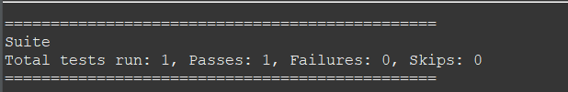

**CLASS EXERCISE 5:**

**ECLIPSE CODE:**

package com.selenium.test2.selenium1;

import org.openqa.selenium.By;

import org.openqa.selenium.WebDriver;

import org.openqa.selenium.WebElement;

import org.openqa.selenium.chrome.ChromeDriver;

import org.openqa.selenium.chrome.ChromeOptions;

import org.testng.annotations.AfterMethod;

import org.testng.annotations.BeforeMethod;

import org.testng.annotations.Test;

import io.github.bonigarcia.wdm.WebDriverManager;

public class D9C5 {

WebDriver driver;

@Test

public void f() throws Exception {

String url="https://opensource-demo.orangehrmlive.com/web/index.php/auth/login";

driver.get(url);

Thread.sleep(3000);

WebElement uname=driver.findElement(By.name("username"));

WebElement pwd=driver.findElement(By.name("password"));

WebElement submit=driver.findElement(By.xpath("//*[@class='oxd-button oxd-button--medium oxd-button--main orangehrm-login-button']"));

uname.sendKeys("Suvitha");

pwd.sendKeys("12345");

submit.click();

String url1="https://opensource-demo.orangehrmlive.com/web/index.php/dashboard/index";

}

@BeforeMethod

public void beforeMethod()

{

WebDriverManager.chromedriver().setup();

ChromeOptions co = new ChromeOptions();

co.addArguments("--remote-allow-origins=*");

driver=new ChromeDriver(co);

}

@AfterMethod

public void afterMethod() {

driver.close();

}

}

**TESTNG CODE:**

<?xml version="1.0" encoding="UTF-8"?>

<suite parallel="false" name="Suite">

<test name="Test">

<listeners>

<listener class-name="com.selenium.test2.selenium1.listr">

</listener>

</listeners>

<classes>

<class name="com.selenium.test2.selenium1.D9C5"/>

</classes>

</test> <!-- Test -->

</suite> <!-- Suite -->

**OUTPUT:**

